Table of Contents

Login the WordPress Admin Console 2

Updated Items via only the WordPress Admin Console 3

Item: “Delete from the home page slider: Julia Greeley, 2013 NABCA Annual Meeting, Another Milestone.” 3

Item: “Update the Contact Information.” 4

Item: “Update the Goals. Add 1979.” 5

Item: “Update the Board of Directors.” 6

Item: “Remove Newsletters.” 8

Item: “Update Calendar of Events.” 9

Item: “Delete Past Events.” 10

Item: “Delete Day Of Reflection.” 11

Items: “Delete Photo Gallery.” 12

Updated Items via File Changes 13

Item: “Delete the Proclamation text box on the home page.” 13

Item: “Remove ‘Copyright © 2011 Jade7.com’ and ‘Design by Jade7.com’.” 14

## Login the WordPress Admin Console

Steps:

1. <http://nabcacatholic.org/wp-login.php>.
2. Username:
3. Password:
4. Select the Log In button.

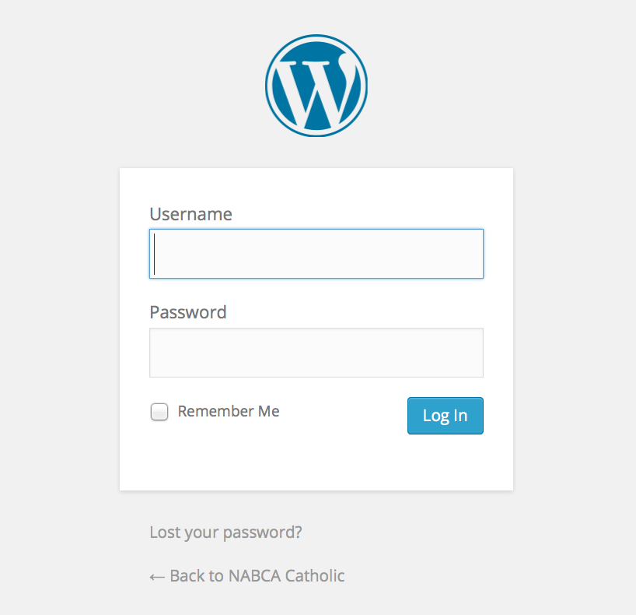

## Updated Items via only the WordPress Admin Console

### Item: “Delete from the home page slider: Julia Greeley, 2013 NABCA Annual Meeting, Another Milestone.”

Steps:

**Change the Category of the Post from “NABCA Slides” to “Uncategorized”**.

Example – Julia Greeley

1. Login the WordPress Admin Console.
2. Select Posts from the left side bar.
3. Select the Julia Greeley link.
4. On the right side bar, change the Category from by checking “NABCA Slides” and uncheck “Uncategorized”.
5. On the right side bar, select the Update button.
6. Repeat steps “a)” through “e)” for 2013 NABCA Annual Meeting and Another Milestone.

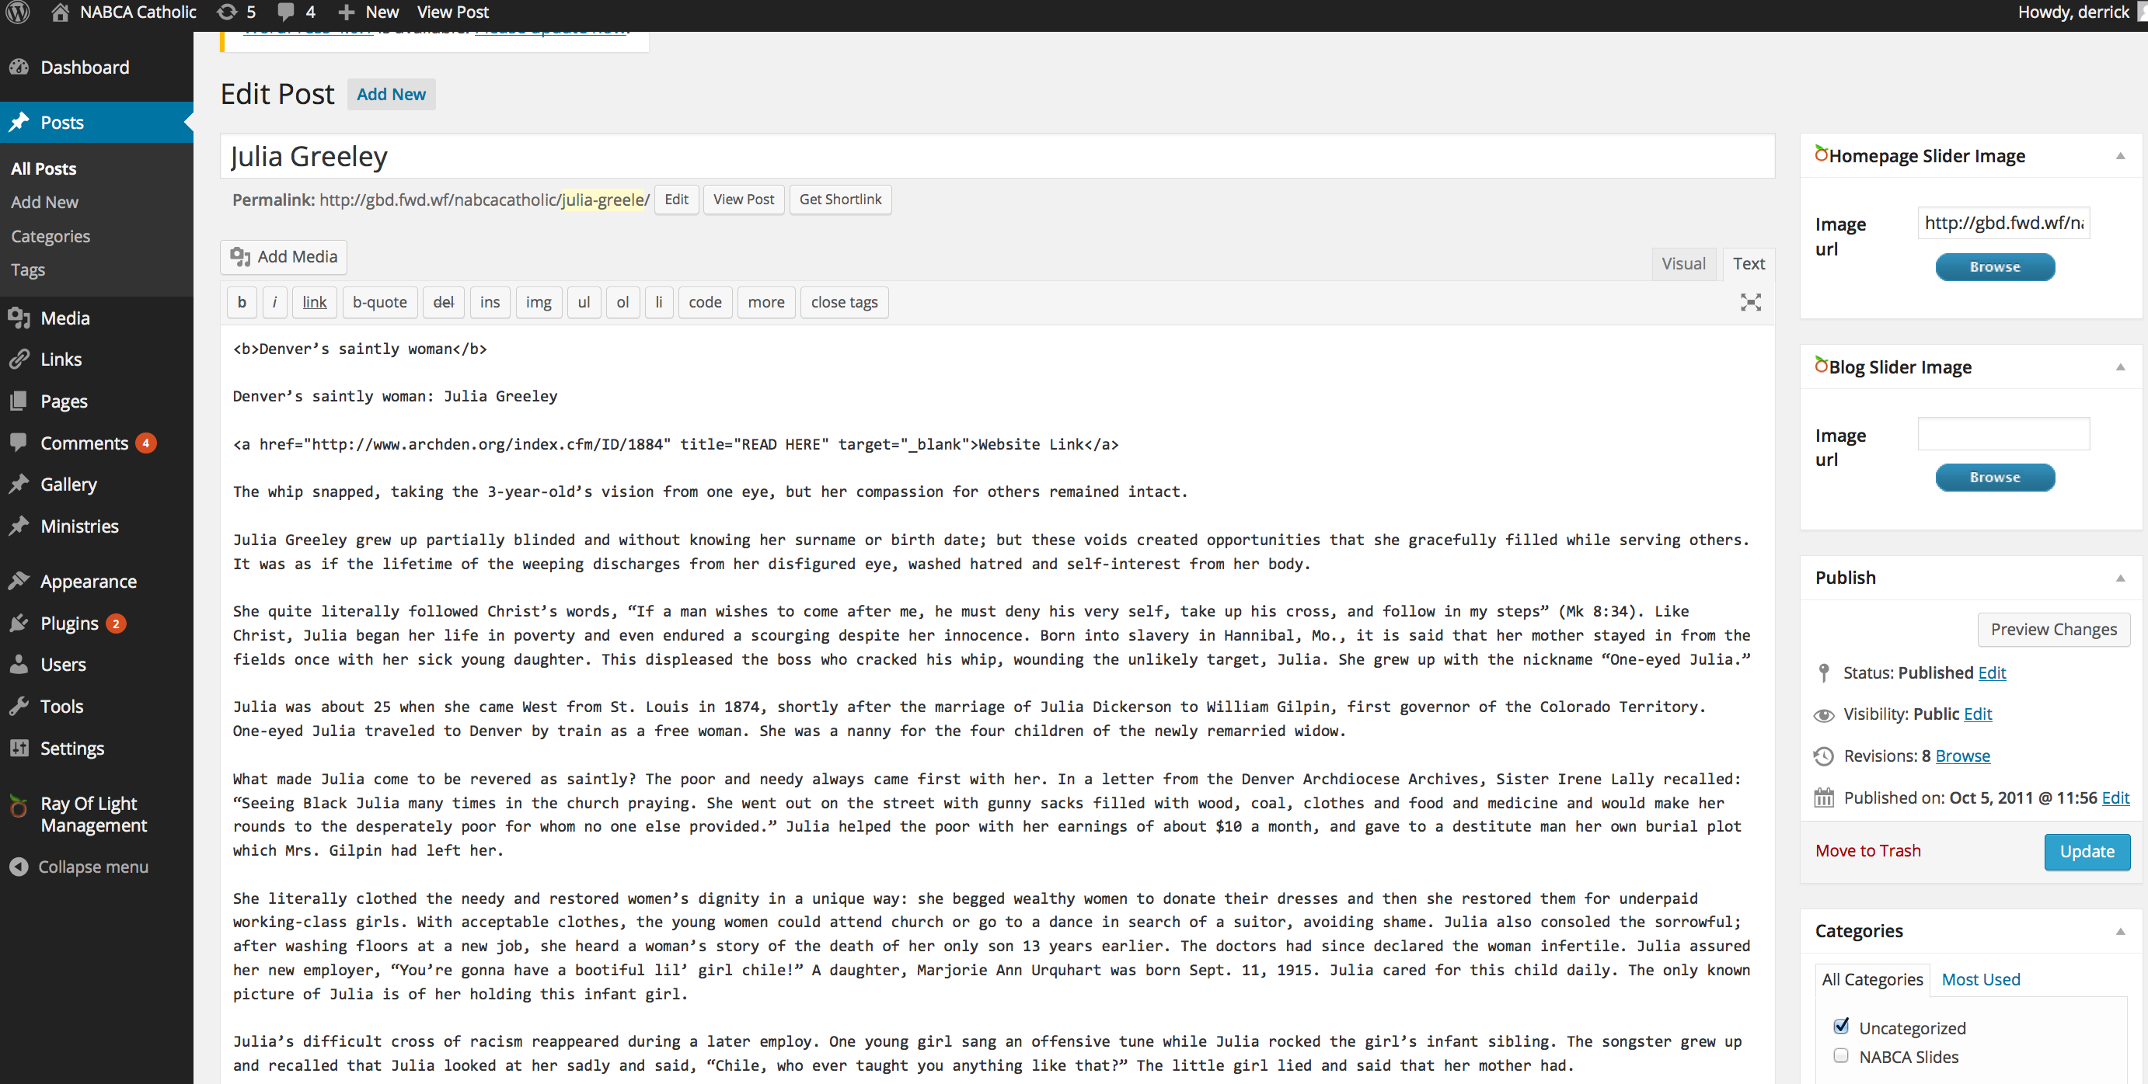

c

### Item: “Update the Contact Information.”

Steps:

1. Login the WordPress Admin Console
2. Select the Ray of Light Management link from the left side bar.
3. Select the Contact tab.
4. Update the Contact tab and select the Save Changes button.

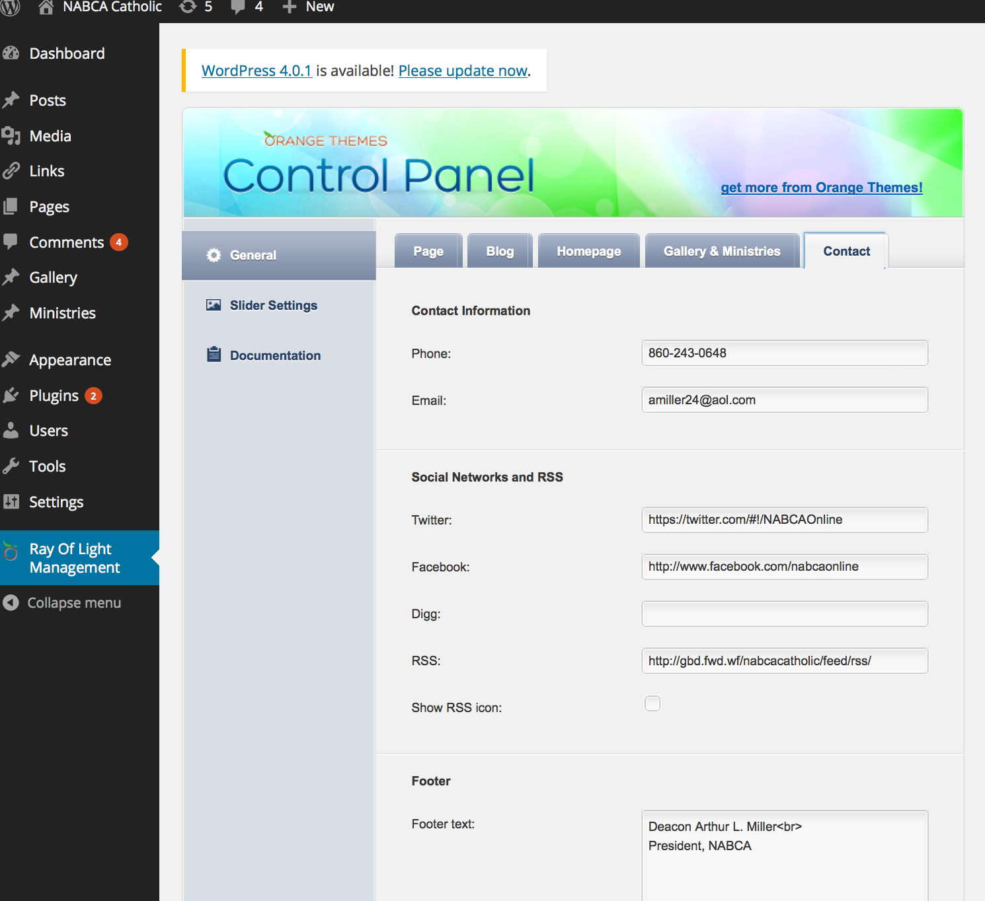

### Item: “Update the Goals. Add 1979.”

Steps:

1. Login the WordPress Admin Console.
2. Select the Pages link from the left side bar.
3. Select the Goals link.
4. Update the content in the text box.
5. Select the Update button on the right side bar.

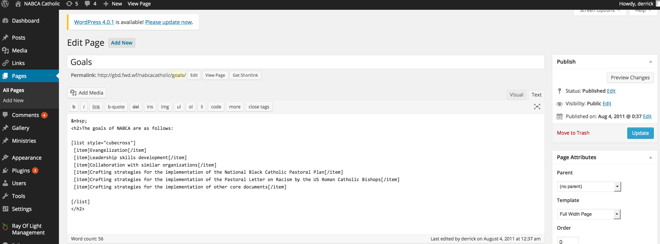

### Item: “Update the Board of Directors.”

* Add Patty January for Region 1.
* Remove Region 1 from Gwen Summers.
* Add John Thorne for Region 6.
* Remove Mary Leisring.
* Add Anderson Shaw for Region 11, 12, 13.
* Add Katrina Reeves-Jackson for Region 14.

Steps:

1. Login the WordPress Admin Console.
2. Select the Pages link from the left side bar.
3. Select the Board of Directors link.
4. Select the Text tab of the content text box.
5. Copy and paste the content from board_of_directors_text_content.txt into the text box.

Note: There are two tabs that display/update the content: Visual and Text. Make sure you copy and paste the contents from board_of_directors_text_content.txt in the Text tab.

1. Select the Update button on the right side bar.

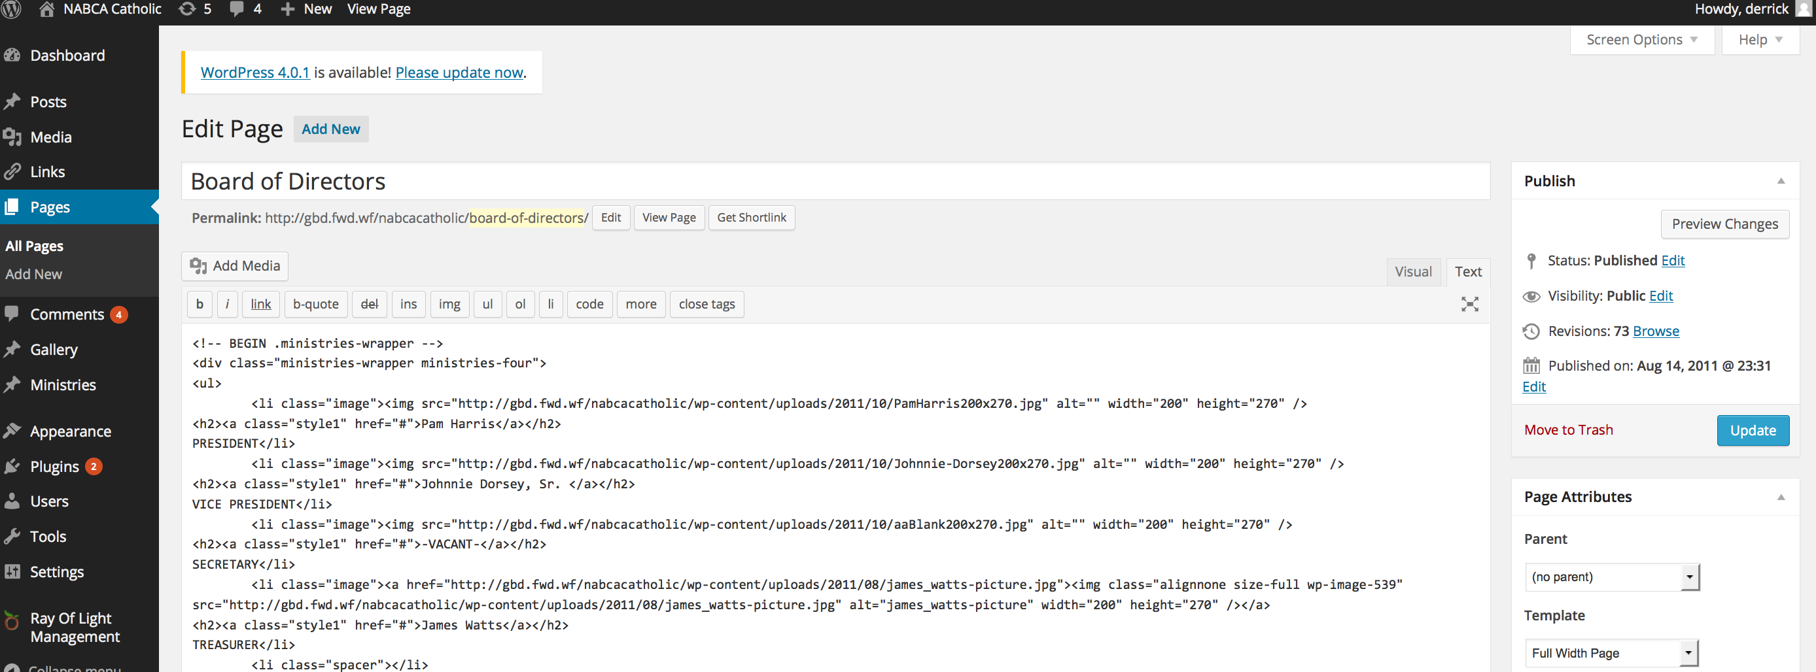

### Item: “Remove Newsletters.”

Steps:

1. Login the WordPress Admin Console.
2. Select the Pages link from the left side bar.
3. Select the Newsletters link.
4. Remove the content in the text box.
5. Select the Update button on the right side bar.

Note: This keeps the Newsletters menu option and provides a blank page.

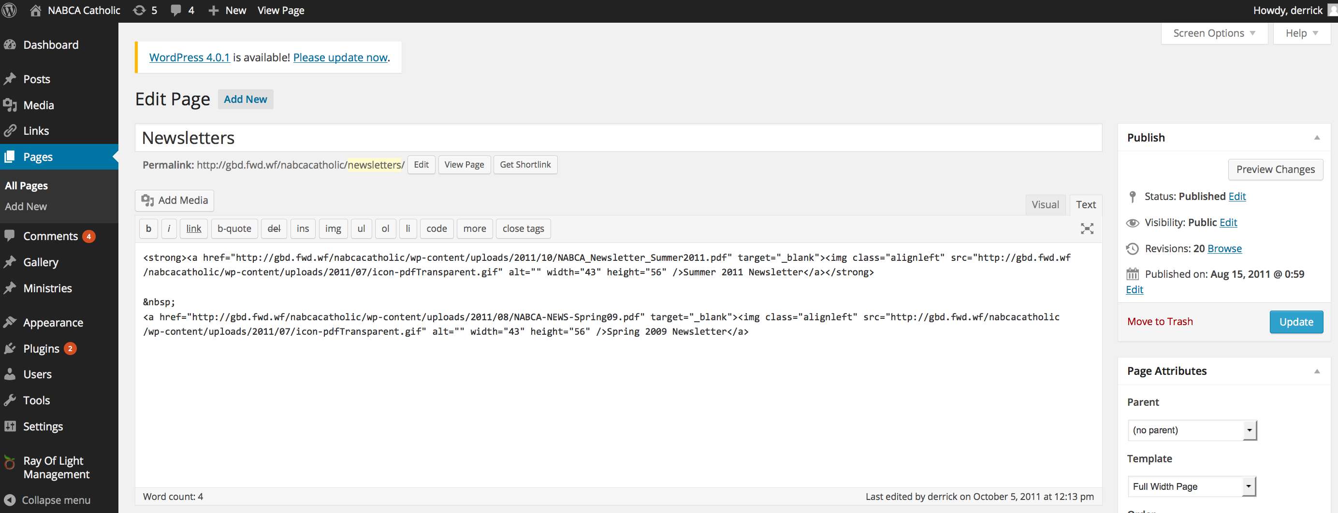

### Item: “Update Calendar of Events.”

Steps:

1. Login the WordPress Admin Console.
2. Select the Posts link from the left side bar.
3. Select the 2013 NABCA Annual Meeting link.
4. Update the content in the text box.
5. Select the Update button on the right side bar.

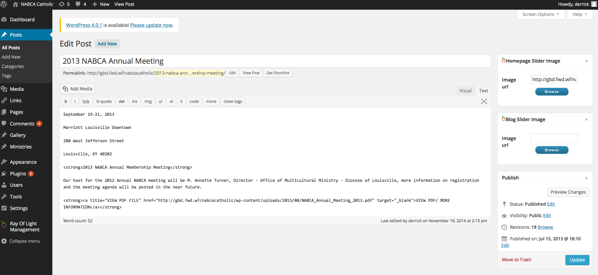

c

### Item: “Delete Past Events.”

Steps:

1. Login the WordPress Admin Console.
2. Select the Posts link from the left side bar.
3. Select the Veneration of Relics of African Saints link.
4. Update the content in the text box.
5. Select the Update button on the right side bar.

Note: This keeps the Past Events menu option and provides a blank page.

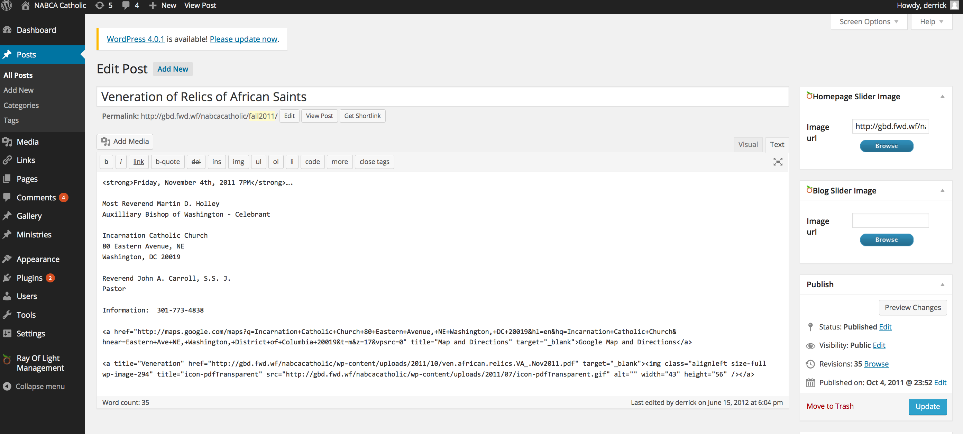

### Item: “Delete Day Of Reflection.”

Steps:

1. Login the WordPress Admin Console.
2. Select the Pages link from the left side bar.
3. Select the DAY OF REFLECTION link.
4. Update the content in the text box.
5. Select the Update button on the right side bar.

Note: This keeps the Day Of Reflection menu option and provides a blank page.

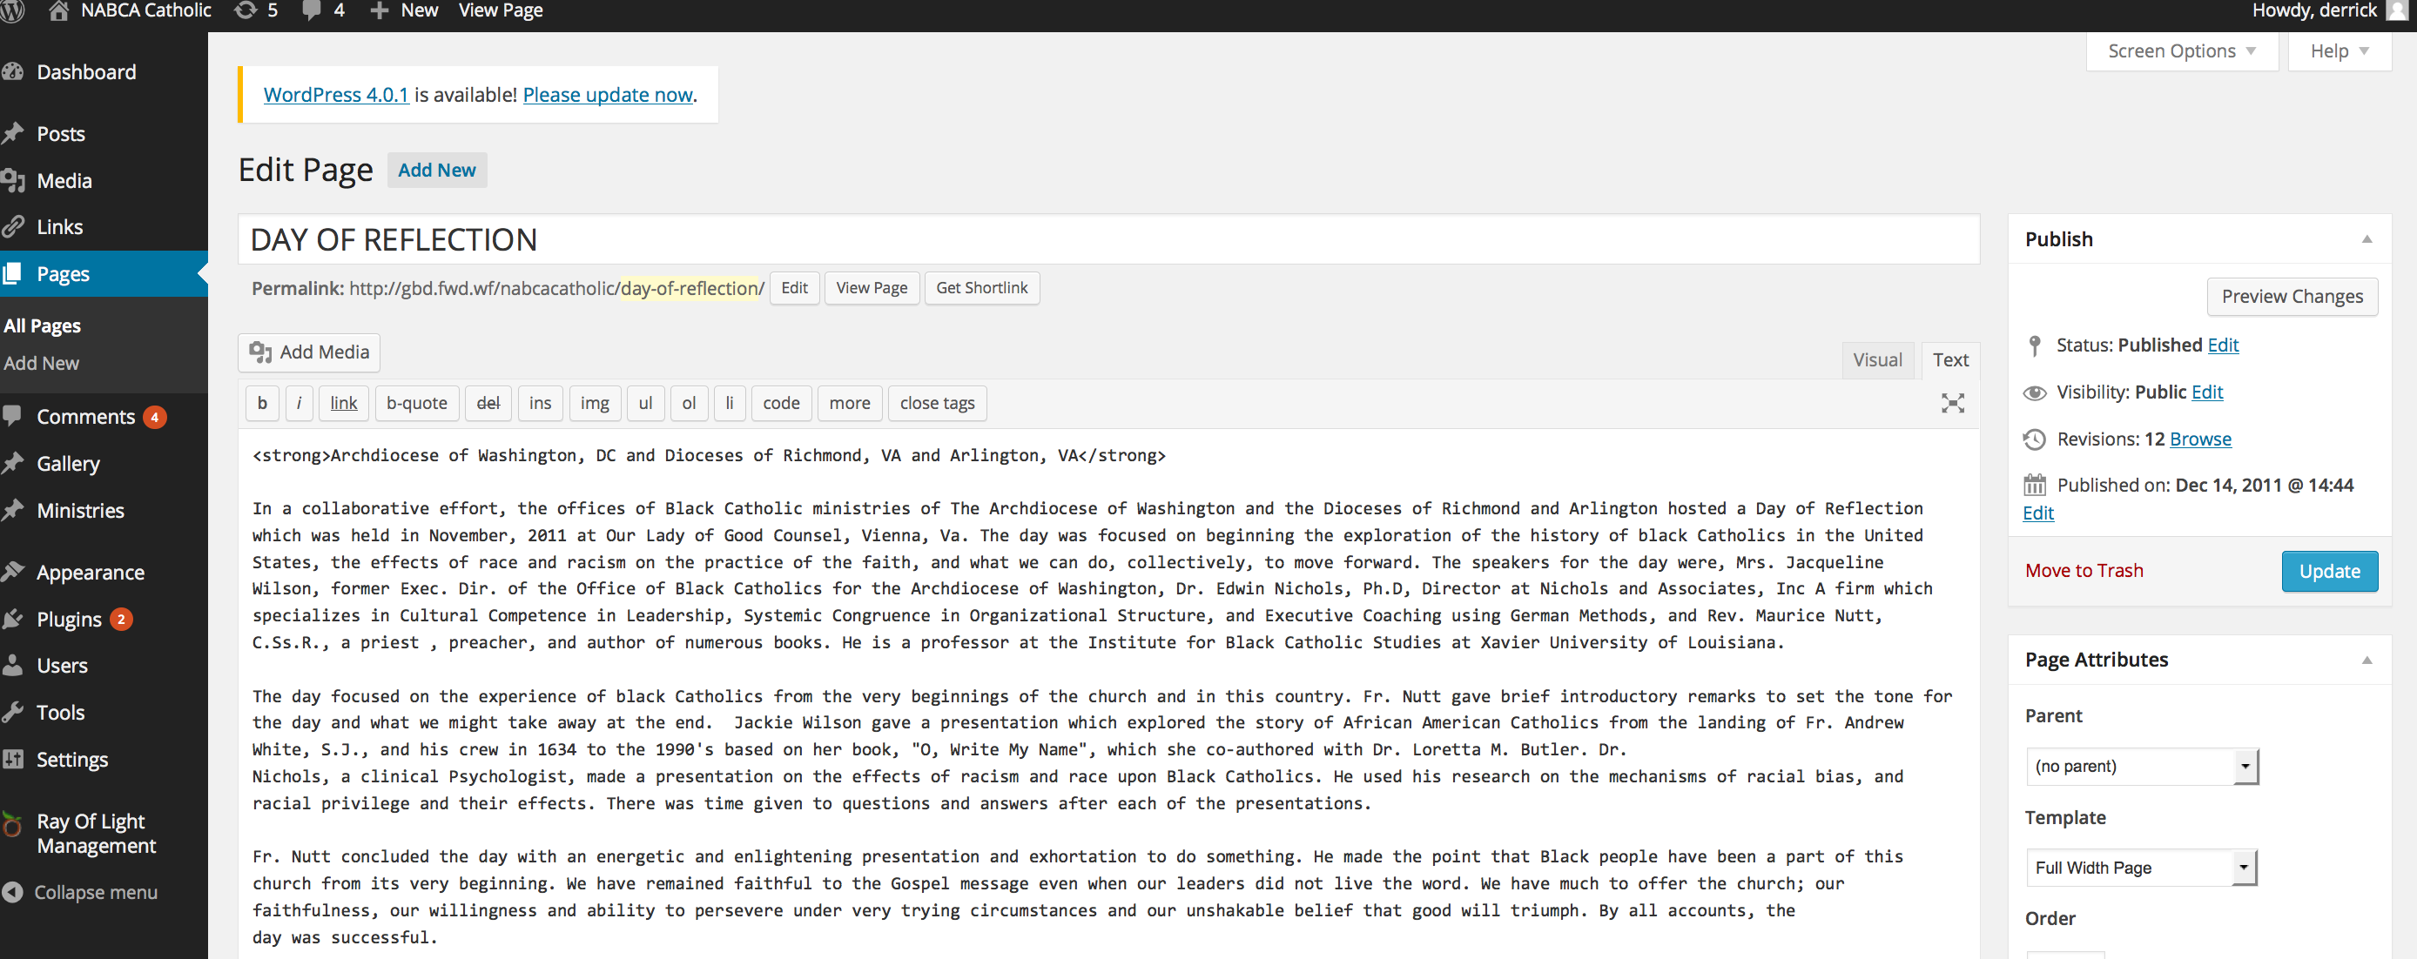

### Items: “Delete Photo Gallery.”

Steps:

1. Login the WordPress Admin Console.
2. Select the Appearance🡪Menu link from the left side bar.
3. Scroll down and select NABCA 2011 Fall Meeting - Pittsburg, PA to expand the box.
4. Select the Remove link.

Note: This removes the NABCA 2011 Fall Meeting - Pittsburg, PA menu option.

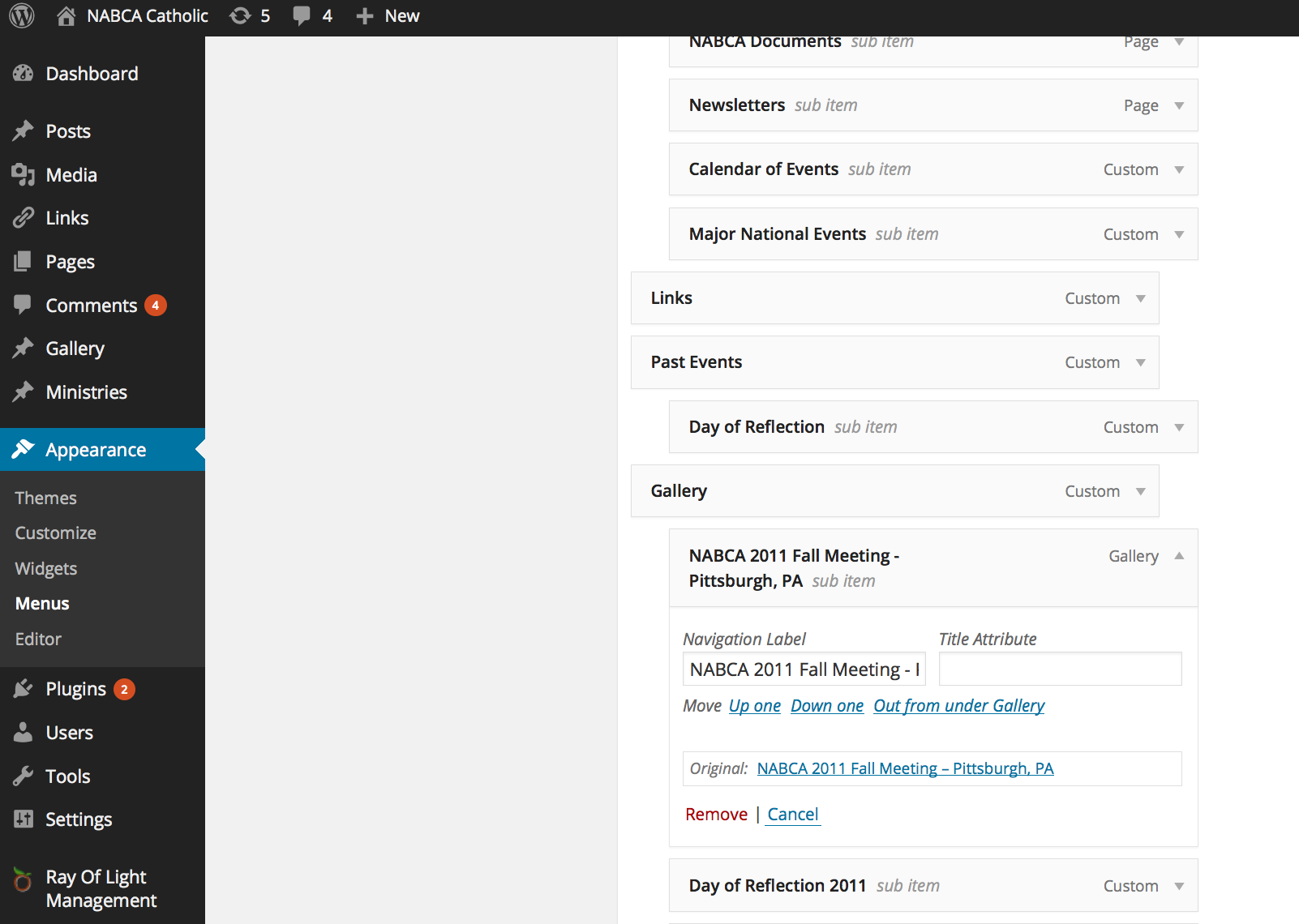

## Updated Items via File Changes

### Item: “Delete the Proclamation text box on the home page.”

Steps:

1. Login ftp account.
   1. Server: nabcacatholic.org
   2. Username:
   3. Password:
2. Replace /wp-content/themes/rayoflight/template-homepage.php with provided template-homepage.php.
3. Replace /wp-content/themes/rayoflight/css/style.css with provided style.css.

Note: Make sure you are replacing the style.css in the /rayoflight/css/ folder.

Result:

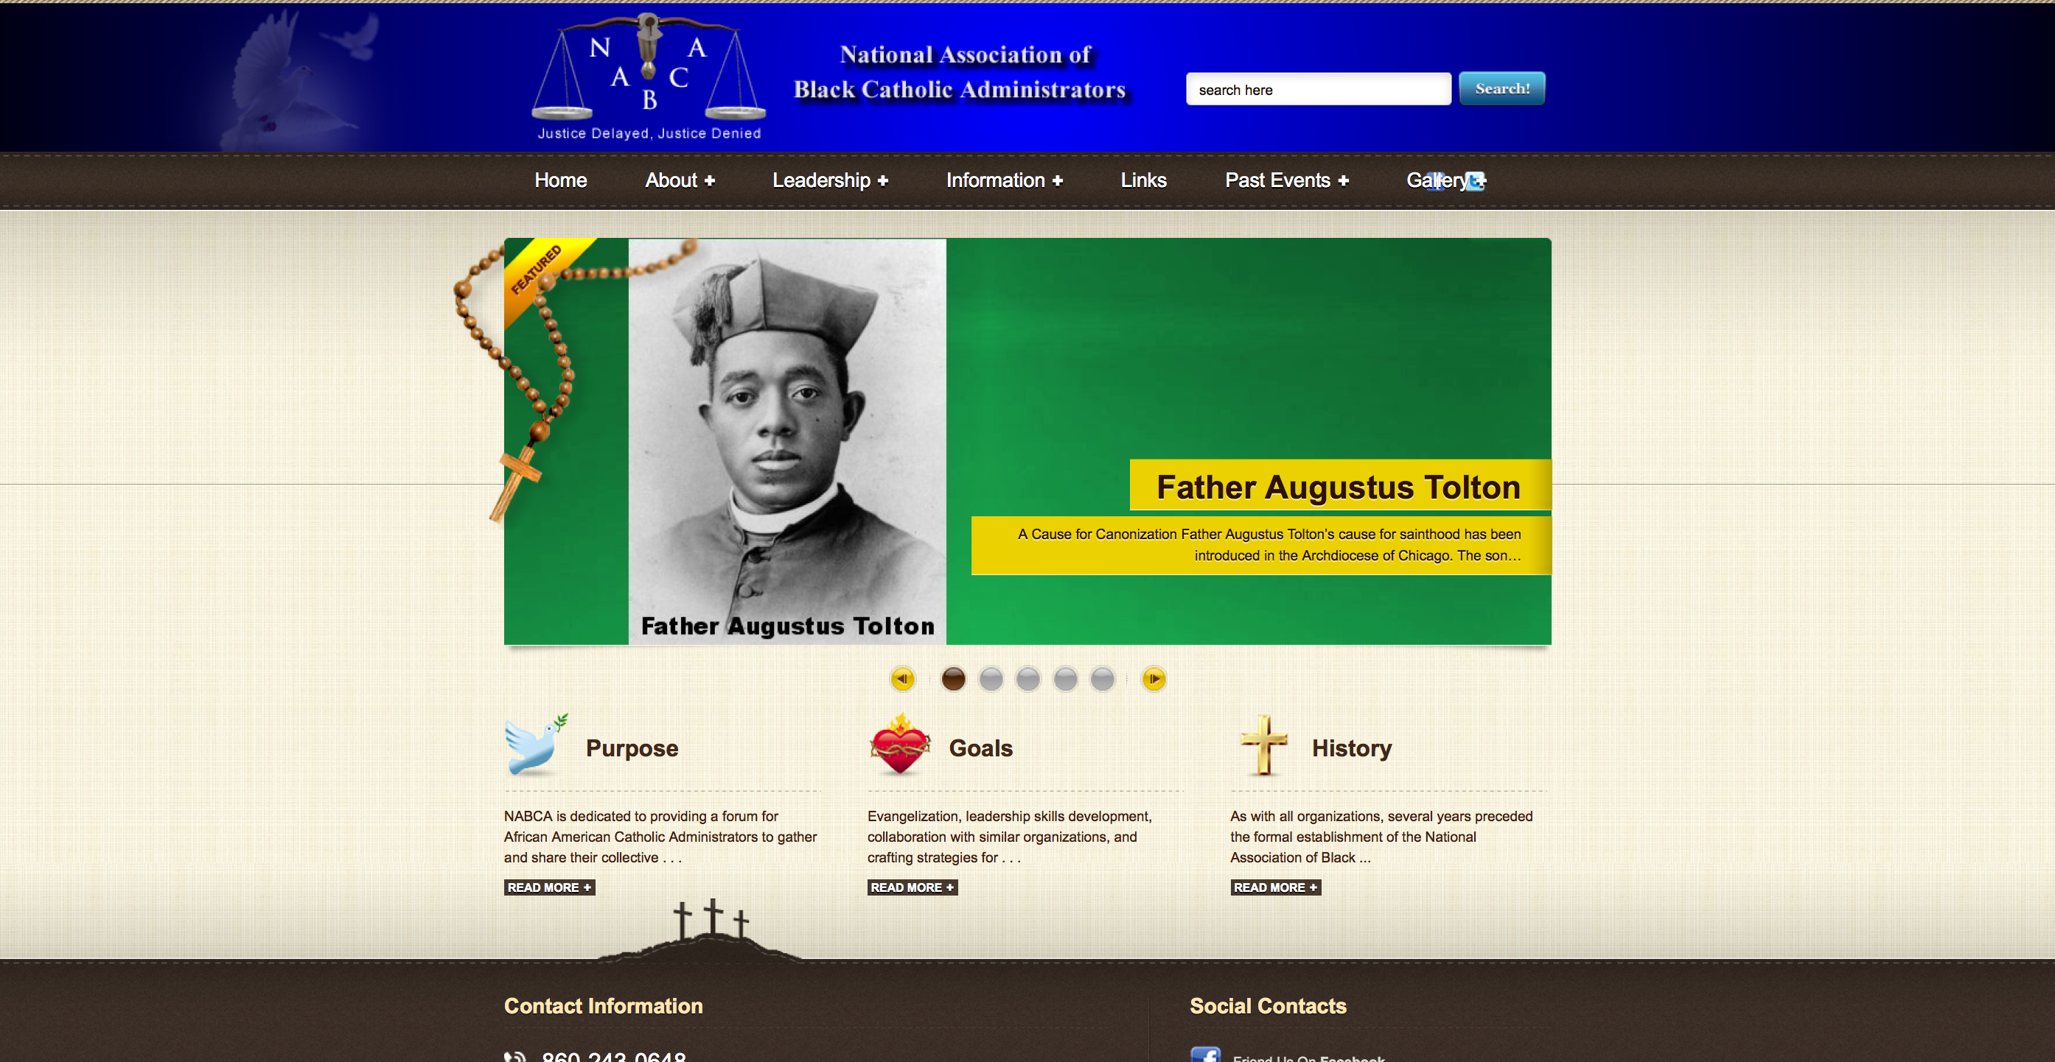

### Item: “Remove ‘Copyright © 2011 Jade7.com’ and ‘Design by Jade7.com’.”

Steps:

1. Login ftp account.
   1. Server: nabcacatholic.org
   2. Username:
   3. Password:
2. Replace /wp-content/themes/rayoflight/footer.php with provided footer.php.

Result:

